**IP (JavaScript + Java Web intro Lab):**

**Task 1: [ Marks: 15]**

Read the code below and try to understand it. Now copy this code and view it in browser.

|  |
| --- |
| <html>  <head>  <script>  function changeColorWhite()  {  //document.getElementById("p1").style.color="red";  document.body.style.backgroundColor="white";  }  function changeColorGreen()  {  document.body.style.backgroundColor="green";  }  function changeColorBlue()  {  document.body.style.backgroundColor="blue";  }  function changeColorRed()  {  document.body.style.backgroundColor="red";  }  function changeColorYellow()  {  document.body.style.backgroundColor="yellow";  }  </script>  </head>  <body style="margin:5%"><h2> Click the Link Below to Change Page BackGround Color</h2>  <table>  <tr><td style="background-color:green"><a onclick="changeColorGreen()" >Change to Green </a></td>  <td style="background-color:red"><a onclick="changeColorRed()" >Change to Red </a></td></tr>  <tr><td style="background-color:blue"><a onclick="changeColorBlue()" >Change to Blue</a></td>  <td style="background-color:yellow"><a onclick="changeColorYellow()" >Change to Yellow </a>  </td></tr>  </table>  <input type="button" value="Back to White" onclick="changeColorWhite()"></input>  </body>  </html> |

This page was changing the styling attributes in java script. Similarly you can change other styling attributes as well.

Attribute Name are same as you used in Styling with CSS, however, there is one difference i.e.

“Any styling attribute having hyphen (-) e.g. background-color, font-style etc. cannot be used as it is in JavaScript code as JavaScript does not support hyphen (-) in name. Such attributes when used in JavaScript should be changed such that hyphen is removed and Character after hyphen is converted to capital case.”

**For example** background-color will be converted to backgroundColor as you can see in above example.

Now, you have to create following page in html.

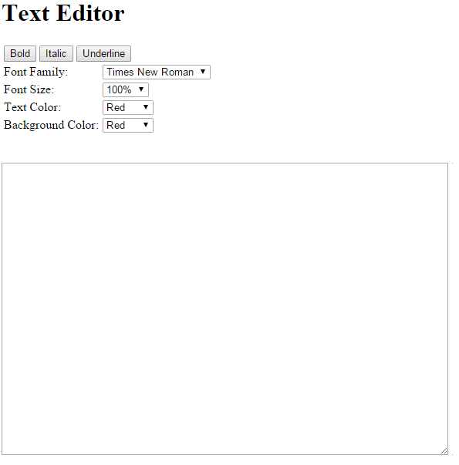

And change styling of textarea control on **onclick** event of buttons and on **onchange** event of dropdown lists. You have to write following functions in <script> tag for these events. I have already written bold button’s function to make it easy for you, complete the remaining functions.

|  |
| --- |
| function bold()  { document.getElementById("ta").style.fontWeight="bold"; }  function italic()  { // Use font-style property to change font to italic }  function underline()  { // Use text-decoration property to change style to underline }  function fontFamily()  { // Use font-family property to change font to selected font }  function fontsize()  { // Use font-size property to change font size to selected font size }  function textcolor()  { // Use color property to change text color to selected color }  function backcolor()  { // Use background-color property to change textarea background color to selected color } |

**Task 2:**

Try to configure and run Java web application example that we discussed in today’s lecture. All the code and step by step instructions are being provided to you (placed at Teacher Data\Aisha\IP\Labs\Post Mid\Afternoon\26 Jan) . You just have to follow all the steps as mentioned and make your **first server side web application.** Do it on your systems/laptops as well before next lecture.

**Note:** provided tomcat as mentioned in guide is for windows 64 bit. If you have 32-bit version this may not work, in that case download apache tomcat for windows 32-bit from internet.

**Task 3:**

Now as you can run the server side code as well. So, you have to create the following page:

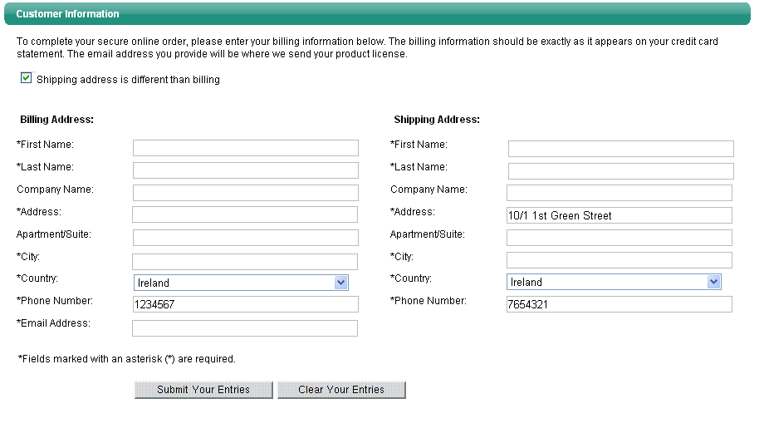

* On click of “clear your Entries” button, call a JavaScript function and clear the text entered by user.
* Put required java script based checks for textboxes with *
* If the user UNCHECKS the check box (shipping address is different from billing address), call a javascript function that will copy all the values from shipping address to billing address as well. This checkbox will be checked by default.
* On click of “submit your entries” button, submit this form to a java servlet and show all the data entered by user.